**Build a Restful API using Node and Mongo DB**

**Recipe1:** **Start MongoDB**

Open Command prompt and type mongod.

Open another Command prompt and type mongo after that type show dbs.

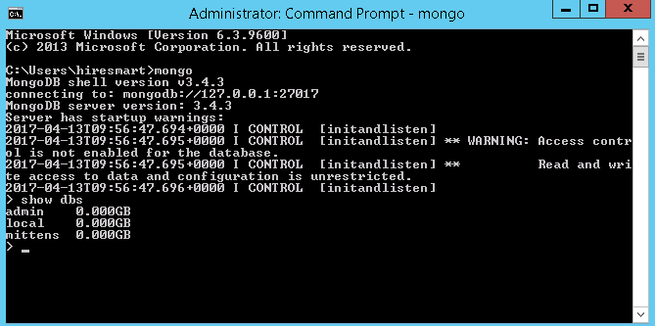

Hurray your database is up now.

**Recipe 2:** **Create a simple Node.js - RESTful API**

Open server.js file from folder C:\src\mittens using Visual studio code or Sublime Text.

And type/copy the below code into it

// server.js

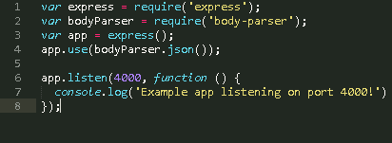

On your terminal, run nodemon server.js this will start the server and then you will see



**Recipe3:** **Using MongoDB with Mongoose**

In server.js in the Base Setup section, let’s add these two lines.

// server.js

// BASE SETUP

// =============================================================================C:\Users\462439\Desktop\7.PNG// mittens is database name

**Racipe4:** **GET /meows – Return all Meows from Mongo DB.**

Now that we are connected to our database, let’s create a mongoose model to handle our meows

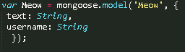

Type/copy the below code into it for Get operation.

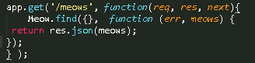

Restart your node server by running: nodemon server.js on your nodemon running terminal.

Great! Now, let’s test it via Postman.

Open your postman and type: http://localhost:4000/meows in the enter request URL section and press enter. You should see following screen. (I added some meows while testing)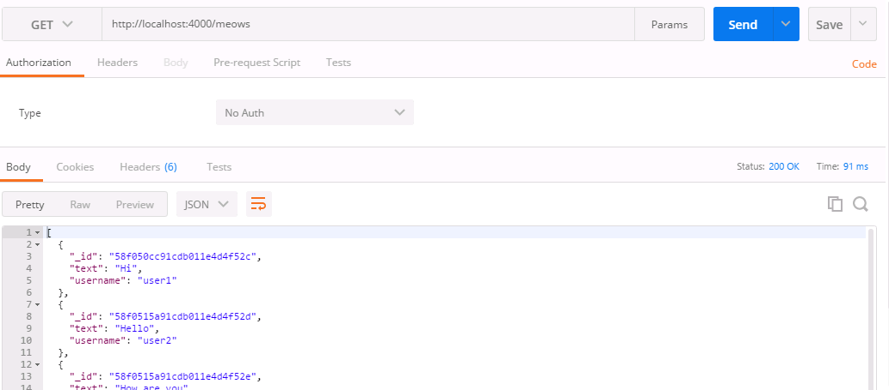

**Recipe5:** **POST /meows – Add new meow in MongoDB.**

Type/copy the below code into server.js for post operation.

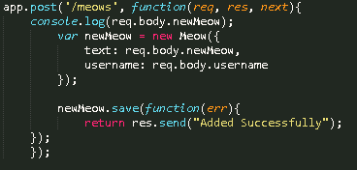

To add new meows in MongoDB, open up POSTMAN, use POST as type and add following in input payload.

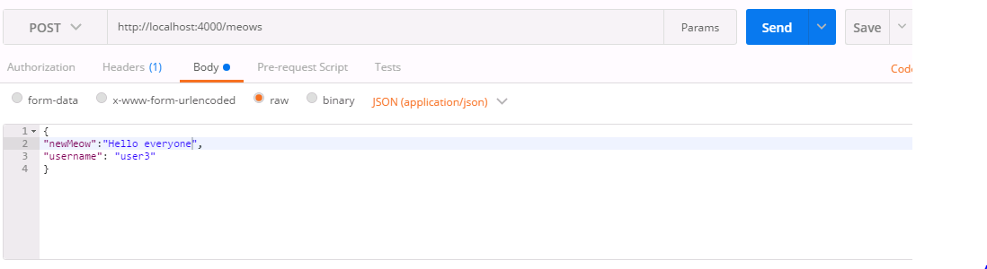

Click on send button and check again Get meows operation and you will get all meows with newly added meow.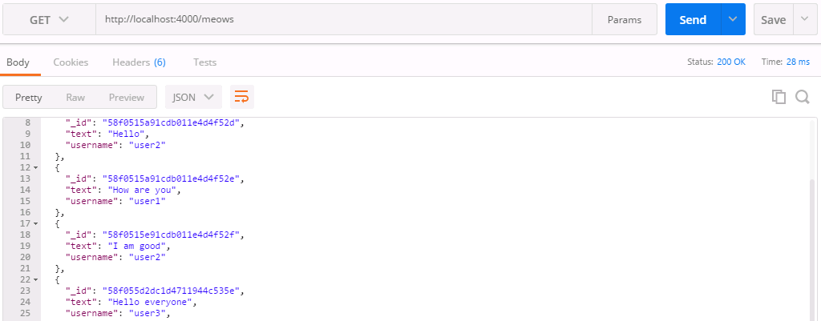

Hurray we have done with get and post operation.

**Recipe6:** **PUT /meows/remove – delete meow in MongoDB.**

Type/copy the below code into server.js for put operation.

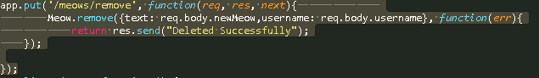

To delete meow from MongoDB, open up POSTMAN, use PUT as type and add following in input payload.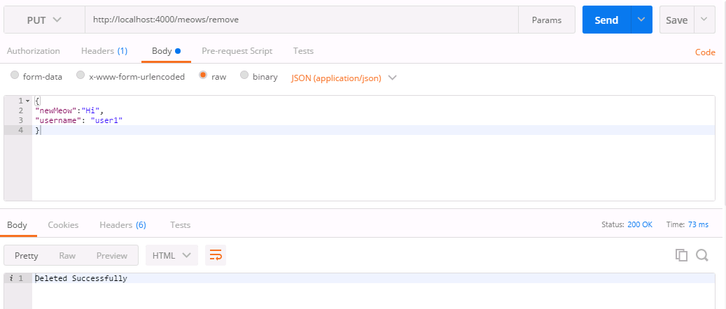

Check with Get meows operation and you will see one meow is deleted.

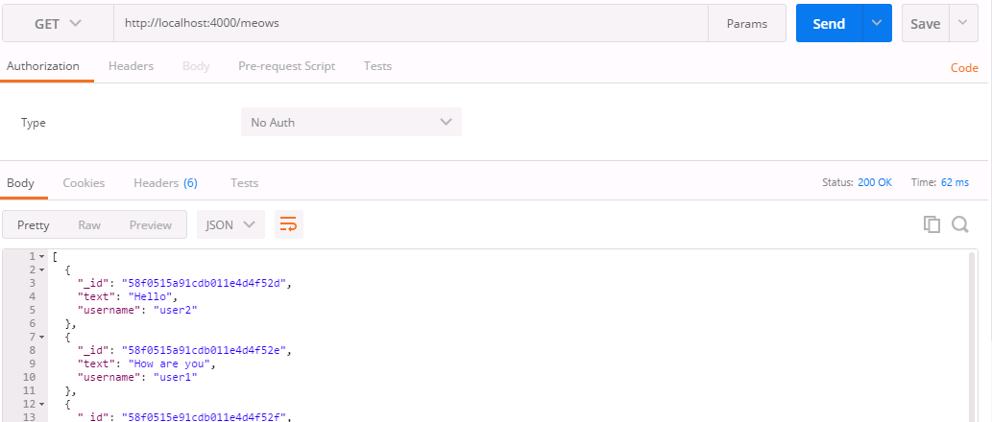

That’s It. Happy Coding!